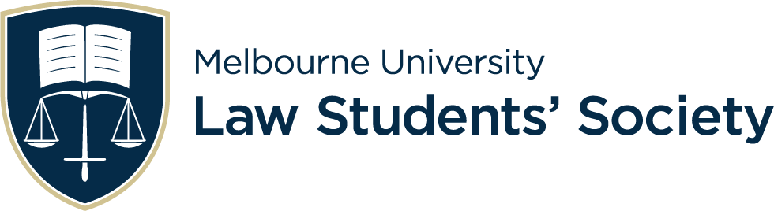
￼￼￼2024 CLIENT INTERVIEW COMPETITION

Team Name: |  | Judge:
Round: |  | Date and Time:
CRITERIA | PERFORMANCE  (Please DO NOT circle or mark this column) |  | COMMENTS  (These are released to competitors) | SCORE
Problem Analysis | Needs work (1 mark)  - Questions were sporadic and uncorrelated, unclear and may have confused the client.  Average (2 marks)  - Understood a few of the main facts, questions followed up some loose ends.  Good (3 marks)  - Followed multiple lines of questioning, followed the client's story and identified key points of contention.  Very good (4 marks)  - Identified a clear timeline of events (if relevant) and worked with the client to ensure their understanding was correct.  Excellent (5 marks)  - Presented logical and clear lines of reasoning, relevant to what the client has said. Questions made sense to the client. |  |  | /5
Secret Facts | Found none (0 marks)  Found one (1 mark)  Found less than half (2 marks)  Found half (round up) (3 marks)  Found most (4 marks)  Found all (5 marks) |  |  | /5
Working Atmosphere | Needs work (1 mark)  - Unengaging and uncaring of the clients personal demeanour.  Average (2 marks)  - May have insulted/scared/intimidated/annoyed the client more than once, did not build a positive environment.  Good (3 marks)  - Accommodated to the clients personal demeanour.  Very good (4 marks)  - Used an appropriate tone and style to work with and not against the client.  Excellent (5 marks)  - Engaged well with the client and were able to be ‘on their side’ so as to work effectively. |  |  | /5
Structure of the Interview | Needs work (1 mark)  - Too casual and informal, bad connection with the client  - Interview went over-time  Average (2 marks)  - Decent communication and a somewhat logical structure, although at some points the flow/structure of the interview was lost or interrupted.  Good (3 marks)  - Professional greeting and introduction, interview flowed logically and aided the questioning.  Very good (4 marks)  - Effective conclusion and explanation of their understanding to the client, as well as a good use of time allocation with the client.  Excellent (5 marks)  - Also advised the client of the next step in regards to their case |  |  | /5
Teamwork & Professionalism | Needs work (1 mark)  - Worked as two individuals and had a poor connection with the client  Average (2 marks)  - Partners may have cut each other off several times or followed completely separate lines of questioning/given conflicting information to the client.  Good (3 marks)  - Good body language and clear, as well as professional and situation-relevant language  Very good (4 marks)  - Appropriate tone and remarks, worked well as a team.  Excellent (5 marks)  - Team members did not cut each other off, worked harmoniously together with relevant questions following each other. |  |  | /5
Post-Interview Reflection | Needs work (1 mark)  - Inaccurate fact summary, omitted the merits of the claim  Average (2 marks)  - Weak fact summary, some inconsistencies  Good (3 marks)  - Accurate account of the facts and/or timeline  - Made an evaluation of the client's personality and ability to pay  Very good (4 marks)  - Well articulated and organised summary, with clear points of contention  Excellent (5 marks)  - Also identified issues that may need further determination before taking the case |  |  | /5
Additional Comments: TOTAL SCORE: _{/30}

